**Project Design Phase-II**

**Data Flow Diagram & User Stories**

|  |  |
| --- | --- |
| Date | 02-10-2025 |
| Team ID | **SWUID20250216599** |
| Project Name | Smart Meet |
| Maximum Marks | 4 Marks |

**Data Flow Diagrams:**

The **Data Flow Diagram (DFD)** of a video conferencing app illustrates the flow of data between users, the system, and external entities. It shows how users register, log in, create or join meetings, exchange audio/video data, and share files. Key processes include User Authentication, Meeting Management, Real-Time Communication, and Data Storage. The diagram highlights data movement among components such as the User Interface, Server, Database, and Media Streaming Module, ensuring secure and efficient communication between participants.

**Entities of Level - 0 DFD :**

* **User (Host/Participant)**
* **Video Conference App System**

**Data Flow:**

1. User → Login/Signup Info → System
2. System → Authentication Result → User
3. User → Meeting Request (Create/Join) → System
4. System → Meeting Data (Link, Participants) → User
5. User ↔ System → Audio/Video Stream

**Data Store:**

* **User Database** (Stores user credentials, profiles)
* **Meeting Database** (Stores meeting details, participants, chat logs)

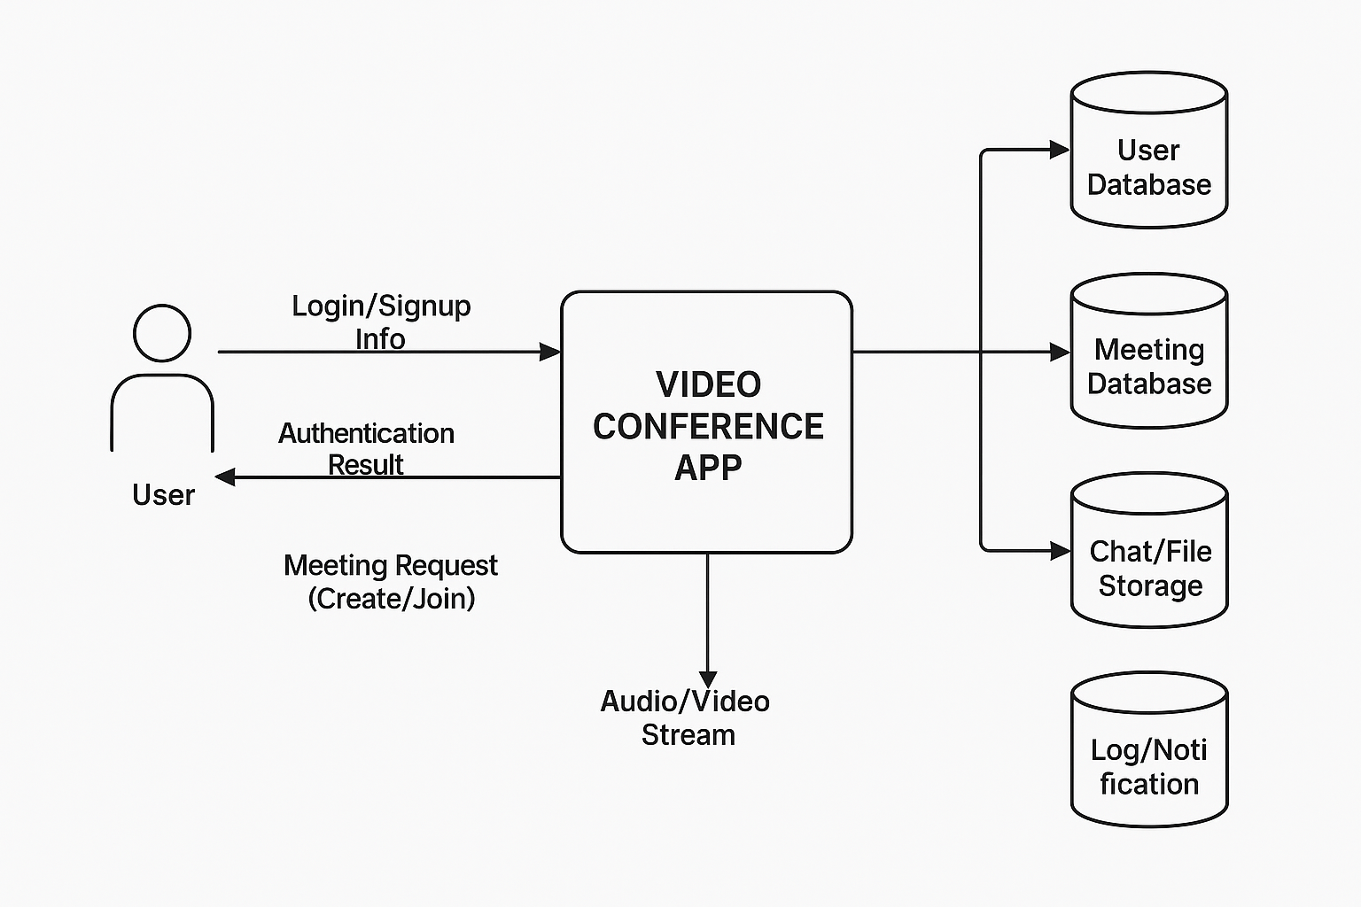

**Level 0 Data Flow Diagram**

**User Stories**

**User Story Table – Video Conferencing App :-**

|  |  |  |  |  |  |
| --- | --- | --- | --- | --- | --- |
| **User Type** | **Functional Requirement (Epic)** | **User Story / Task** | **Acceptance Criteria** | **Priority** | **Release** |
| User | Authentication | As a user, I can register and log in securely using my credentials. | Successful login redirects to dashboard; invalid credentials show error. | High | Sprint-1 |
| Host | Meeting Creation | As a host, I can create and schedule a meeting with a unique meeting ID/link. | Meeting link generated and saved in the database. | High | Sprint-1 |
| Participant | Join Meeting | As a participant, I can join a meeting using a valid meeting link or ID. | Participant successfully joins live meeting. | High | Sprint-1 |
| User | Audio/Video Control | As a user, I can mute/unmute audio and turn video on/off during meetings. | User’s audio/video toggles in real time. | Medium | Sprint-2 |
| User | Screen Sharing | As a user, I can share my screen with others during the meeting. | Screen sharing visible to all participants. | Medium | Sprint-2 |
| User | Chat & File Sharing | As a user, I can send text messages and share files during the meeting. | Messages/files delivered instantly to all participants. | High | Sprint-2 |
| User | Recording Meeting | As a host, I can record the meeting for future reference. | Recorded file saved to cloud storage. | Medium | Sprint-3 |
| Admin | User Management | As an admin, I can view, edit, or deactivate user accounts if needed. | Changes reflected in the database. | Medium | Sprint-3 |